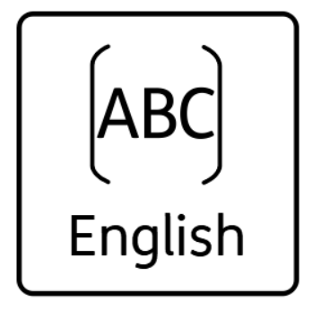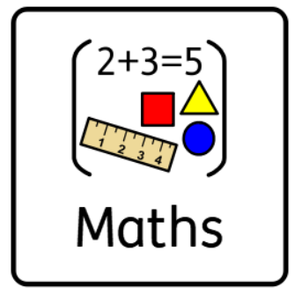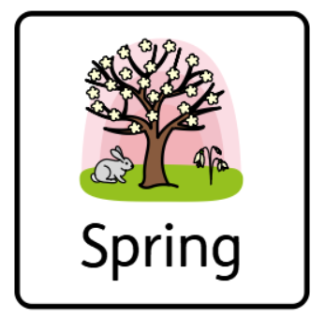

This terms Topic is ‘Fairy Tales’! It would be great if you could get to the library and have a look at some books on the topic or if you have some at home send us a picture! 😊

Some other things we’d love to hear about happening at home are; playing board games together, learning to get dressed independently, sharing books, going for walks, riding scooters and other fun things that make great memories.

In maths we are learning about numbers, patterns and shape. Continuing to practise counting at home is a great help and let’s see how high you can go!!! More and less is also great vocabulary to learn.

Shapes are all around us and we love going on shape hunts around school. Could you go on one near you and take some pictures with what you see?

We are also learning about patterns. Can you make patterns at home with fruit, teddy’s or toys? What about outside with sticks and leaves?

Class 5

Homework Ideas