***H2 spring home learning ideas.***

***Topic: Let it grow, let it grow.***

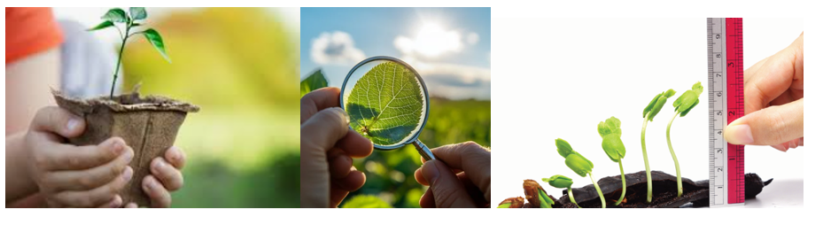

***Indoor Continuous Provision Activities***

1. Plant Exploration Station

* Resources:
* Magnifying glasses
* Various types of plants (real or artificial)
* Petri dishes
* Soil samples
* Clipboards and pencils

Set-up Instructions:

Set up a table with an array of different plants and soil samples. Provide magnifying glasses for children to closely observe the textures and details of the plants.

Questions to Ask:

* What do you notice about the leaves of this plant?
* Can you describe the texture of the soil?
* How do you think these plants grow?

2. Plant Growth Timeline

Resources:

* Paper and coloured pencils
* Images of plants at various growth stages (seed, sprout, mature plant, flower)
* Scissors and glue

Set-up Instructions:

Create a space for children to create a visual timeline of plant growth using the provided images and their drawings.

Questions to Ask:

* How does a plant change over time?
* What do you think plants need to grow?
* Can you draw your favourite stage of a plant’s life?

3. Sensory Garden

Resources:

* A variety of herbs (mint, basil, etc.)
* Textured materials (sandpaper, soft fabric)
* Water spray bottles

Set-up Instructions:

Fill a large tray with herbs and textured materials. Allow children to explore the scents and feel of different plants.

Questions to Ask:

* How does this herb smell?
* What does this texture remind you of?
* Can you think of a dish that uses this herb?

***Outdoor Continuous Provision Activities***

1. Garden Planting

Resources:

* Pots or recycled containers
* Soil
* Seeds (sunflowers, beans, etc.)
* Watering can

Set-up Instructions:

Designate a planting area outside with available pots and gardening tools. Explain the process of planting seeds to the children.

Questions to Ask:

* What do we need to do to help our plants grow?
* How deep should we plant the seeds?
* What will happen if we don’t water them?

2. Nature Scavenger Hunt

Resources:

* Scavenger hunt lists (pictures or words)
* Clipboards and pencils
* Baskets for collecting items

Set-up Instructions:

Create a scavenger hunt list that includes different types of plants, leaves, seeds, and flowers. Take children outside and let them search for these items.

Questions to Ask:

* What can you find that is green/yellow/red?
* How many different types of leaves can you collect?
* What do you think this plant needs to survive?

3. Plant Art Zone

Resources:

* Natural materials (leaves, flowers, twigs)
* Paper and glue
* Paint and brushes

Set-up Instructions:

Create an outdoor art area with natural materials. Encourage children to create art pieces inspired by the plants around them.

Questions to Ask:

* How can you use this leaf in your artwork?
* What colours do you see in nature?
* Can you make a picture of a plant using these materials?